Compound Interest Calculator

### Description

This program calculates the future value of an investment given the principal amount, interest rate, and number of years.

### Input

* Principal amount
* Annual interest rate
* Number of years

### Output

The future value of the investment for each year, from 1 to the number of years specified.

### Example

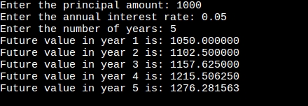

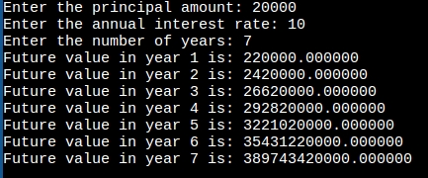

### Notes

* The interest rate is assumed to be compounded annually.
* The future value is calculated using the formula:

future_value = principal * pow(1 + interest_rate, years)

where:

* future_value:is the future value of the investment
* principal:is the principal amount
* interest_rate:is the annual interest rate
* years:is the number of years